Southwest Petroleum University
Graduation Thesis
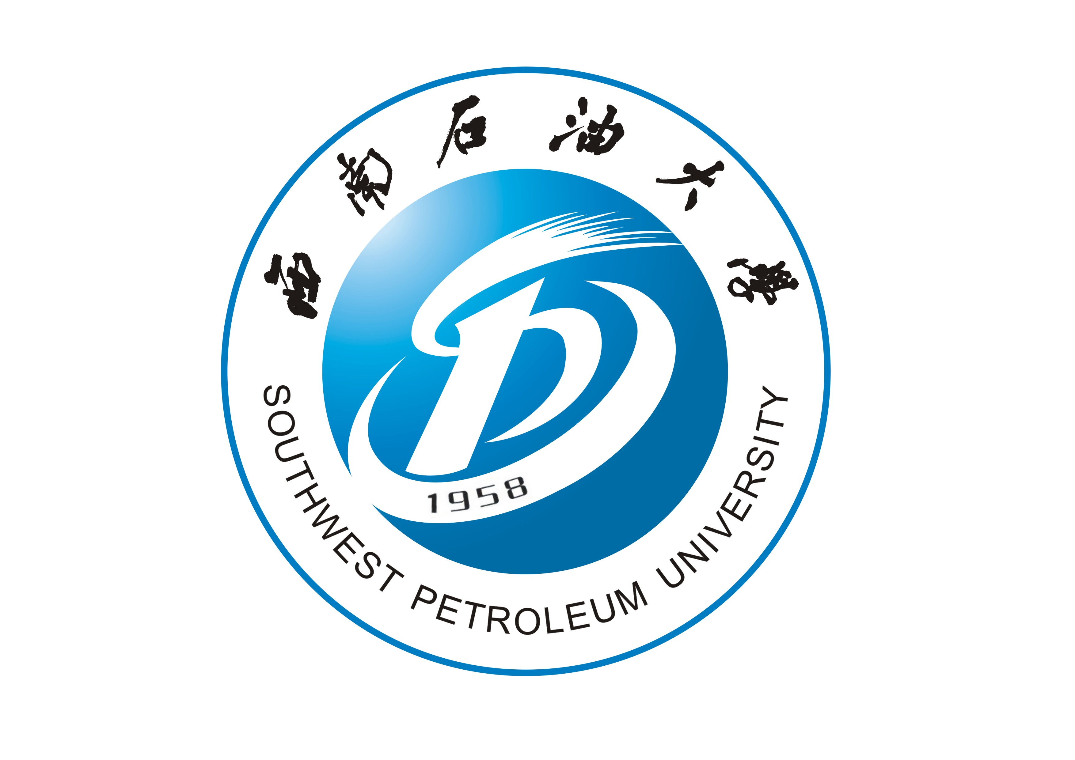

Research on Government Procurement System

Grade: 2013
Name:
Speciality: Petroleum Engineering
Instructor:

School of Petroleum and Gas Engineering
2017-6

附：
我校2013级设置的专业中英文对照
院系名 | 专业名 | 英文专业名
石油与天然气工程学院School of Petroleum and Gas Engineering | 石油工程 | Petroleum Engineering
石油与天然气工程学院School of Petroleum and Gas Engineering | 油气储运工程 | Oil & Gas Storage and Transportation Engineering
石油与天然气工程学院School of Petroleum and Gas Engineering | 海洋油气工程 | Offshore Oil and Gas Engineering
地球科学与技术学院School of Geoscience and Technology | 勘查技术与工程 | Exploration Technology and Engineering
地球科学与技术学院School of Geoscience and Technology | 地质学 | Geology
地球科学与技术学院School of Geoscience and Technology | 城市地下空间工程 | City Underground Space Engineering
地球科学与技术学院School of Geoscience and Technology | 资源勘查工程 | Resource Prospecting Engineering
地球科学与技术学院School of Geoscience and Technology | 地理信息科学 | Geography Information Science
机电工程学院School of Mechanical and Electrical Engineering | 机械设计制造及其自动化 | Mechanical Design & Manufacturing and Automation
机电工程学院School of Mechanical and Electrical Engineering | 测控技术与仪器 | Measurement Control Technology and Instruments
机电工程学院School of Mechanical and Electrical Engineering | 工业设计 | Industrial Design
机电工程学院School of Mechanical and Electrical Engineering | 机械电子工程 | Mechatronics Engineering
机电工程学院School of Mechanical and Electrical Engineering | 机械工程 | Mechanical Engineering
机电工程学院School of Mechanical and Electrical Engineering | 过程装备与控制工程 | Process Equipment and Control Engineering
化学化工学院School of Chemistry and Chemical Engineering | 环境工程 | Environmental Engineering
化学化工学院School of Chemistry and Chemical Engineering | 应用化学 | Applied Chemistry
化学化工学院School of Chemistry and Chemical Engineering | 化学工程与工艺 | Chemical Engineering and Technology
化学化工学院School of Chemistry and Chemical Engineering | 安全工程 | Safety Engineering
化学化工学院School of Chemistry and Chemical Engineering | 化学 | Chemistry
材料科学与工程学院School of Materials Science and Engineering | 材料科学与工程 | Materials Science and Engineering
材料科学与工程学院School of Materials Science and Engineering | 高分子材料与工程 | Polymer Materials and Engineering
材料科学与工程学院School of Materials Science and Engineering | 新能源材料与器件 | New Energy Material and Devices
材料科学与工程学院School of Materials Science and Engineering | 材料成型及控制工程 | Materials Processing and Controlling Engineering
计算机科学学院School of Computer Science | 信息管理与信息系统 | Information Management and Information Systems
计算机科学学院School of Computer Science | 计算机科学与技术 | Computer Science and Technology
计算机科学学院School of Computer Science | 网络工程 | Network Engineering
计算机科学学院School of Computer Science | 软件工程 | Software Engineering
计算机科学学院School of Computer Science | 物联网工程 | Internet of Things Engineering
电气信息学院School of Electrical Engineering and Information Science | 电气工程及其自动化 | Electrical Engineering and Automation
 | 电子信息工程 | Electronic Information Engineering
 | 自动化 | Automation
 | 通信工程 | Telecommunication Engineering
土木工程与建筑学院School of Civil Engineering and Architecture | 测绘工程 | Geodesy and Geomatics Engineering
土木工程与建筑学院School of Civil Engineering and Architecture | 城乡规划 | Urban and Rural Planning
土木工程与建筑学院School of Civil Engineering and Architecture | 土木工程 | Civil Engineering
土木工程与建筑学院School of Civil Engineering and Architecture | 建筑环境与能源应用工程 | Building Environment and Energy Engineering
土木工程与建筑学院School of Civil Engineering and Architecture | 工程管理 | Construction Management
理学院School of Sciences | 电子信息科学与技术 | Electronic Information Science and Technology
理学院School of Sciences | 应用物理学 | Applied Physic
理学院School of Sciences | 信息与计算科学 | Information and Computing Sciences
理学院School of Sciences | 数学与应用数学 | Mathematics and Applied Mathematics
经济管理学院School of Economics and Management | 国际经济与贸易 | International Economics and Trade
经济管理学院School of Economics and Management | 电子商务 | Electronic Business
经济管理学院School of Economics and Management | 经济学 | Economics
经济管理学院School of Economics and Management | 市场营销 | Marketing
经济管理学院School of Economics and Management | 工商管理 | Business Administration
经济管理学院School of Economics and Management | 公共事业管理 | Public Affairs Management
经济管理学院School of Economics and Management | 会计学 | Accounting
法学院School of Laws | 法学 | Law
法学院School of Laws | 社会工作 | Social Work
外国语学院School of Foreign Languages | 俄语 | Russian
外国语学院School of Foreign Languages | 英语 | English
体育学院School of Physical Education | 体育教育 | Physical Education
艺术学院School of Arts | 广播电视编导 | Broadcasting and Television Playwright-director
艺术学院School of Arts | 播音与主持艺术 | The Art of Announcing and Anchoring
艺术学院School of Arts | 表演 | Performing Art

